Rock Cycle Lab
Problem: To stimulate the changes that occurs during the rock cycle.
Background Information: The ROCK CYCLE is a diagram that shows the slow, continuous process of rocks changing from one type to another. The Rock Cycle is a series of changes. Igneous rock can change in to sedimentary rock or into metamorphic rock. Sedimentary rock can change into metamorphic rock or into igneous rock. Metamorphic rock can change in igneous or sedimentary rock.
The rock cycle is an illustration that is used to explain how the three rock types are related to each other and how earth processes change a rock from one type to another through geologic time.
A trip through the rock cycle takes millions of years!

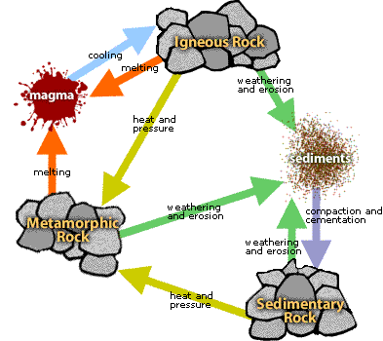

Materials:
Sugar Cube Candle Foil Magnifying glass Goggles

Procedure: Complete the questions using complete sentences.
- Examine the sugar cube with a hand lens. How is the sugar cube like sedimentary rock? Explain

____________________________________________________________________

____________________________________________________________________

- Crush the sugar cube into a powder. What part of the rock cycle does this represent? Explain

____________________________________________________________________

____________________________________________________________________

- Make a ‘boat’ with the foil. Pour the crushed sugar into the foil boat. What part of the rock cycle does this movement represent? Explain

____________________________________________________________________

____________________________________________________________________

- Place foil over the candle. Make sure the boat is tall enough that it does not touch the flame. Observe the sugar as it begins to melt. What part of the rock cycle does this represent? Explain

_____________________________________________________________________

_____________________________________________________________________

- Blow out candle, set the foil boat aside and let the sugar cool and harden. What part of the rock cycle does this represent? Explain

_____________________________________________________________________

_____________________________________________________________________

- Break the hardened sugar into pieces. What part of the rock cycle does this represent? Explain

______________________________________________________________________

______________________________________________________________________
Conclusion:

Describe in your own words how the rock cycle works.
____________________________________________________________________
_____________________________________________________________
_____________________________________________________________
_____________________________________________________________
_____________________________________________________________
_____________________________________________________________
_____________________________________________________________
_____________________________________________________________
_____________________________________________________________
_____________________________________________________________
_____________________________________________________________
_____________________________________________________________

